Preparing the Application for Conformity Assessment of Materials
Introduction
The principles of the functioning of the System for Conformity Pre-Assessment of Materials, including the procedure for submission of applications, conformity assessment of materials and inclusion of materials into the Register of Materials and their exclusion from the Register of Materials, are set forth in Sadales tīkls AS Regulations on the System for Conformity Assessment of Materials (hereinafter referred to as the Regulations).
The Regulations are published in the sub-section System for Conformity Assessment of Materials under the section Procurements on the website of Sadales tīkls AS www.sadalestikls.lv .
Applications may be submitted only for those materials the technical specifications of which are published in the sub-section System for Conformity Assessment of Materials, List of Technical Specifications under the section Procurements on the website of Sadales tīkls AS www.sadalestikls.lv .
The submitted and already assessed materials are collected in the Register of Materials, which is published in the sub-section System for Conformity Assessment of Materials, Register of Materials under the section Procurements on the website of Sadales tīkls AS www.sadalestikls.lv. Before preparing the offer, it is necessary to make sure that the material of a particular manufacturer and type is not already included in the Register of Materials.
The Supplier shall submit the following documents for conformity assessment of the Materials offered:
    - The application letter in accordance with the form provided in Annex 1 to the Regulations with the table of contents of the documents submitted.
    - The technical offer confirming that the Materials offered correspond to the technical requirements indicated for the particular Material.
- PREPARING THE application letter
The Supplier shall submit a separate Application for Conformity Assessment of Materials for each technical specification of the Materials. It is allowed to combine only the technical specifications of uniform materials with common accompanying documents in one application.
The potential supplier shall complete all fields contained in the template of the Letter of Application for Conformity Assessment of Materials, including the table provided in the application letter (Fig. 1), indicating precisely the materials for which the conformity assessment of Materials is requested.
Fig. 1. Table of the application letter
Instructions for completing the table of the application letter:
- In column 1 “Category number of the Material assigned by Sadales tīkls AS” of the Table, specify the material category number assigned to the particular material by Sadales tīkls AS which consists of 7 digits.
The material category number can be found in the section “Designation of the type” in the technical specification of the relevant material. An example of a category number is given in Figure 2, where the category number assigned to the material “1 kV power cable with five aluminium cores and a cross section of 5x16 mm²” in the Sadales tīkls AS category register is 0803.008.
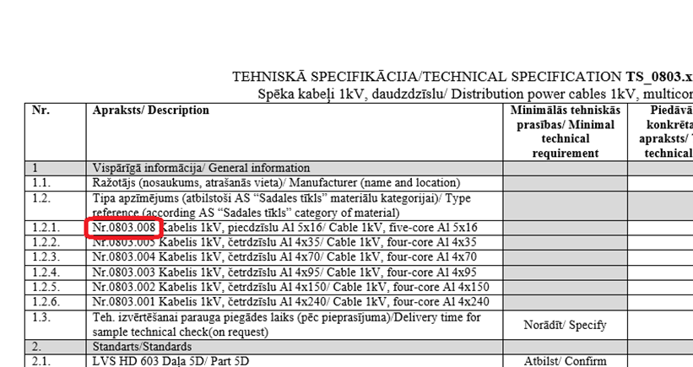
Fig. 2. Category number of the Material in the technical specification
- In column 2 “Category name of the Material assigned by Sadales tīkls AS” of the Table, specify the material category name assigned to the particular material by Sadales tīkls. The name of the material can be found in the section “Designation of the type” in the technical specification of the relevant material. An example of a category name is given in Figure 3, where the 1 kV power cable with five aluminium cores and a cross section of 5x16 mm²” is selected.
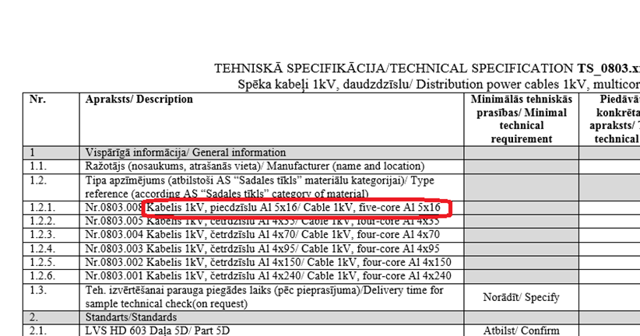
Fig. 3. Name of the material in the technical specification
- In column 3 “Name of the manufacturer of the Material and the country of manufacture” of the Table, the Supplier shall specify the name of the manufacturer of the Material offered and the country where it is manufactured.
- In column 4 “Full designation of the type of the Material” of the Table, the Supplier shall specify the full and exact name of the type assigned to the Material.
An example of the completed table of the Letter of Application for Conformity Assessment of Materials is given in Figure 4.
No. | Category number of the Material assigned by Sadales tīkls AS | Category name of the Material assigned by Sadales tīkls AS | Name of the manufacturer of the Material and the country of manufacture | Full designation of the type of the Material
1. | 0803.008 | Cable 1kV, five-core Al 5x16 | Draka Keila Cables AS, Estonia | AXPK-PLUS 5G16
2. | 0803.004 | Cable 1kV, four-core Al 4x70 | Draka Keila Cables AS, Estonia | AXPK-PLUS 4G70
3. | 0803.001 | Cable 1kV, four-core Al 4x240 | Draka Keila Cables AS, Estonia | AXPK-PLUS 4G240
Fig. 4. Example of the completed table of the application letter
- PREPARING THE Technical offer
The technical offer confirms that the Materials offered conform to the technical requirements indicated for the particular Material.
The conformity shall be proven by:
- the accurately and fully completed technical specifications of the relevant Materials published on the website of Sadales tīkls AS;
- the documents describing the Materials offered which are specified in the requirements for the technical specifications of the relevant Materials (such as copies of type tests by laboratories accredited in Europe and accreditation certificates of the laboratories, instructions for use, photographs, etc.). The documents to be submitted as indicated in the technical specification.
The Supplier shall group and label the documentation supporting the conformity of the materials offered in such a way that it can be clearly understood which document refers to which material. It is desirable to place the files of the documentation supporting the technical conformity of each material in separate folders with identifiable names describing their contents.
The technical specifications of a material are technical requirements defined by Sadales tīkls AS, which are summarised in the table of technical requirements for a relevant material or a group of materials.
The technical specification table is comprised of the columns with a list of technical requirements defined by Sadales tīkls AS and the columns to be completed by the Supplier to demonstrate the conformity of the Material offered to the technical requirements of Sadales tīkls AS. An example of a technical specification table is given in Figure 5.
Fig. 5. Table of the Technical Specification of the Materials
Instructions for completing the technical specification table:
- Columns 1 and 2 of the Table contain a description of the requirements determined by Sadales tīkls AS for a particular material, a group or a sub-group of materials.
- Column 2 of the Table contains minimal technical requirements, and in case of non-fulfilment of these requirements the material offered may be rejected as an offer not conforming to the technical requirements of Sadales tīkls AS.
- The Supplier shall complete columns 3, 4 and 5 of the Table:
  - In column 3, the Supplier shall indicate the characteristics of the Material offered that comply with the relevant requirement. The conformity of the data entered in column 3 of the technical specifications must be demonstrated by the documents indicated in column 4.
  - In column 4, the Supplier shall provide references (links) to a file that justifies or proves the fulfilment of the relevant technical requirement (files of the documents supporting the fulfilment of the requirement). If the file contains information that relates to several items of the requirements in the technical specification, reference shall be provided to the page or a specific section or sub-section of the document.
  - In column 5, the Supplier may specify additional information or references explaining the conformity of the Material offered to the technical requirements of Sadales tīkls AS.
An example of the completed technical specification table is given in Figure 6.
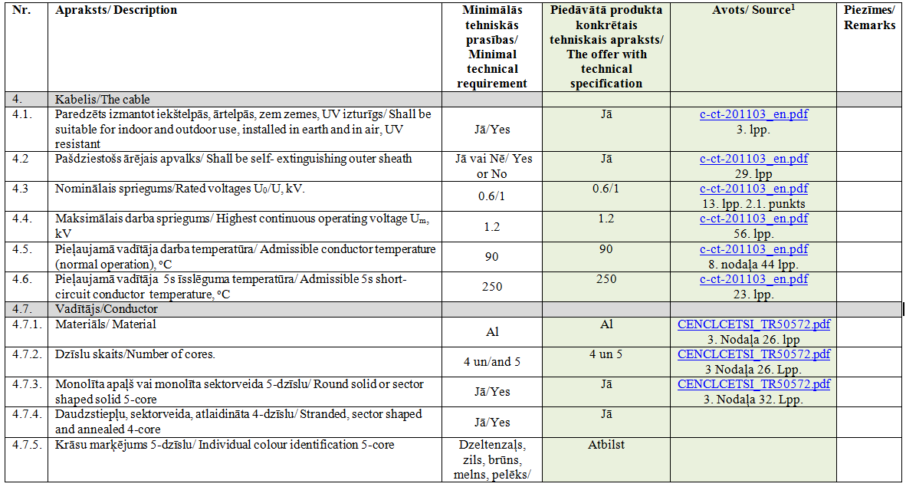
Fig. 6. Example of the completed technical specification table

